

*shell programming lab*

aSsignment -6

**SUBMITTED BY: SUBMITTED TO:**

**AYUSH KUMAR JHA Dr. Dhiviya Rose**

**SAP ID - 500086400**

**Enrollment no - R200220083**

**B.C.A -I.O.T.**

**EXPERIMENT – 6**

**TITLE:** Working with grep command.

**Text Content**

unix is great os. unix is opensource. unix is free os.

learn operating system.

Unix linux which one you choose.

uNix is easy to learn.unix is a multiuser os.Learn unix .unix is a powerful.

**Activities:**

1. Write a grep command that selects the lines from the file1 that have exactly three characters.

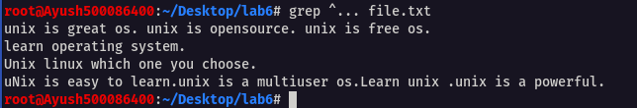

1. Write a grep command that selects the lines from the file1 that have at least three characters.

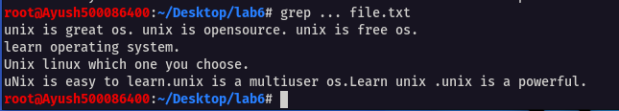

1. Write a grep command that selects the lines from the file1 that have three or fewer characters

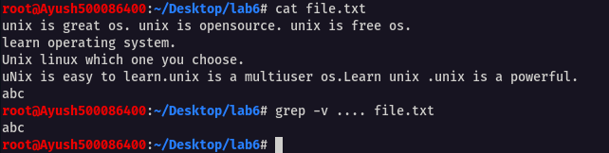

1. Write a grep command that counts the number of blank lines in the file1

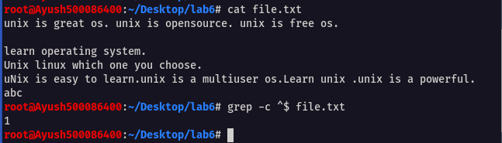

1. Write a grep command that counts the number of nonblank lines in the file1.

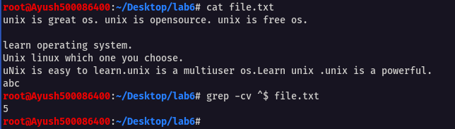

1. Write grep command that selects the lines from file1 that have the string UNIX.

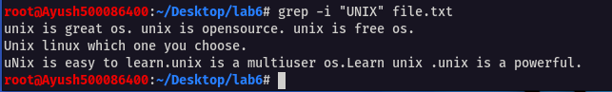

1. Write grep command that selects the lines from file1 that have only the string UNIX.



1. Write grep command that copies the file to the monitor, but delete the blank lines.

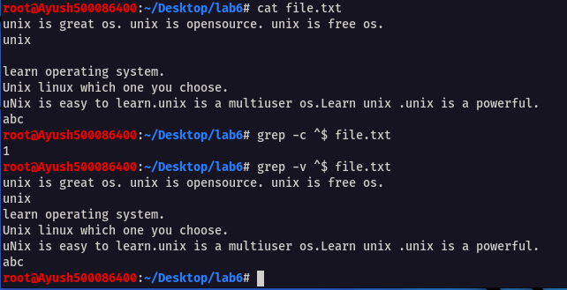

1. Write grep command that selects the lines from file1 that have at least two digits without any other characters in between.

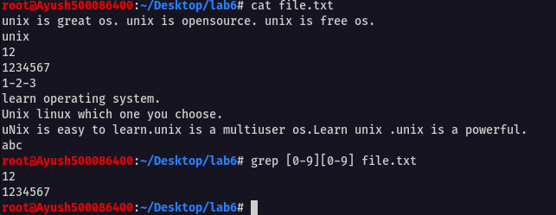

1. Write grep command that selects the lines from file1 that do not start with A to G.

